Relationships 1

As individuals we have relationships with many different people. Just as the people are different, so are the relationships.

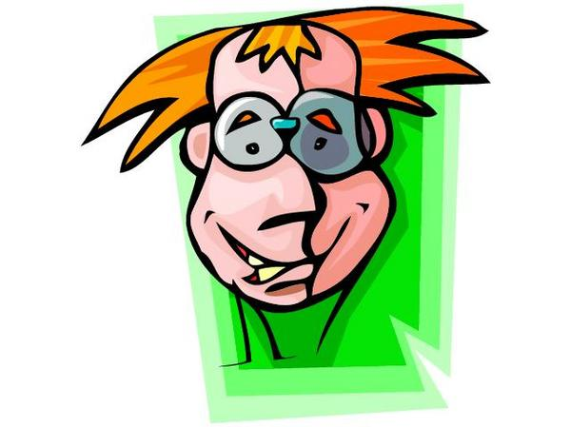

PERSON
Relationship to them

In the bubbles list the people in your life and your relationship to them.

